Team Name

Team Contract – COMP229 – Web Application Development

# Members

Donna Marie Brar – 301369346 – [dmvbrar@gmail.com](mailto:dmvbrar@gmail.com) / +1 647 267 4197‬

Jesus Carlo Borlagdan – 301378794 – +1 (437) 868-4919

J Byre Aguilar – 301312086 – +1 437 665 6960

Yu Du – Student Number – Contact Information

Agwo Tekeh Maxmillian Afanga – 301325202 – +1 4165614002

Cyril Vergara –301324609 – +63 915 539 0569 (WhatsApp)

# Team Expectations

We understand that throughout the Course, all team members are designated as Developers. By the end of the Semester, we will have a functioning (and somewhat polished) web application prototype using the MERN Stack (MongoDB, ExpressJS, React and NodeJS)

All team members must be able to communicate decisions, techniques, and processes related to all aspects of the development process for our web application. Below, we have outlined specific expectations for all team members to adhere to, as well as the consequences for failing to meet each expectation:

## Meeting times

Team meetings will occur XXXXX. If a member is late, absent, …

## Other Requirements (add additional as needed)

Details of Expectations

Recourse for failing to meet expectations

How members can fix any problems and remove any consequences of failing to meet expectations

## Sample Expectation: Getting Help

If a team member is assigned a task that they are not confident in completing, we expect that the member in question informs the rest of the team before the next meeting. Another group member will be designated to help the member in question learn and complete their task. If the group as a whole is unsure or doesn’t feel confident, we will follow the following steps to get help outside of the group:

1. Ask the professor
2. Approach other students for help
3. … and so on

If a member is unable to complete a task on time or unable to meet the group’s quality standards because they needed help but did not seek it out, the group will give them a web application development topic (MERN Stack related) to learn about and teach to the rest of the group within the next 2 team meetings.

If a member continually fails to contribute meaningfully, we will approach the professor to meet with our team and discuss next steps.

Once a team member has fulfilled their obligations and either taught the team a new concept or followed up with the Instructor, they will be able to reintegrate to the team’s workflow without further recourse.

## Other Requirements

Details of Expectations

Recourse for failing to meet expectations

How members can fix any problems and remove any consequences of failing to meet expectations

# Consequences and Corrective Actions

In the event that Team Requirements are not met, some of the repercussions may include having a team member ‘flagged’ as unproductive. Any member who is flagged will receive a grade of 0 (zero) on all following review sessions until the flag is removed.

Should a team member break one of the above expectations to the point where they should be flagged (outlined in your expectations), please see your professor with evidence of the issue (including which part of the contract has been broken and any corrective steps taken prior to flagging), and the member will be flagged and the conditions to remove the flag will be recorded. At that point it is up to the flagged member to meet those conditions and provide evidence to have their flag removed.

Flagged members will be notified of their status and removal conditions by the instructor.

Amendments  
Should the team determine an aspect of the contract is no longer relevant or wish to add a new  
section, they will be permitted to amend the contract. This must be formally written, signed by all  
members, and then attached to the original contract. Please include a description of the  
amendment, the affected clauses, and the date it takes effect.

# Agreement

We, the team of <TEAM NAME> have come up with these expectations together and agree to adhere to them throughout the academic term. We understand our own rules and the consequences for breaking them. We also agree that we have read and understood the material in the course syllabus

Signed,

Name: _Donna Marie Brar_____________ Signature: ___________________ Date_Feb. 26, 2024__

Name: _J Byre Aguilar_________________ Signature: ___________________ Date_Mar. 05, 2024_

Name: _Yu Du________________________ Signature: ___Y D_____________ Date_Mar.8,2024__

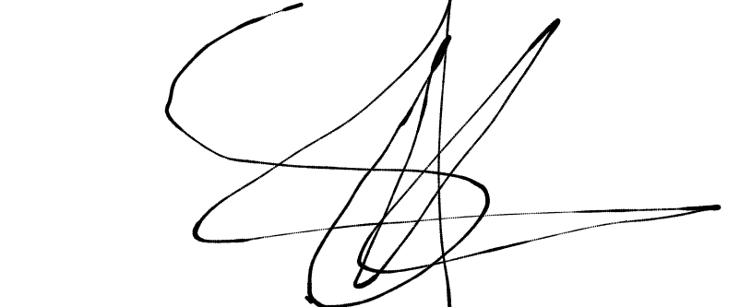

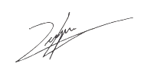Name: _Agwo Tekeh Maxmillian Afanga Signature: ____________________Date_Mar.08,2024

Name: _Cyril Vergara__________________ Signature: ___________________ Date__Mar. 05, 2024_

Name: _Jesus Carlo Borlagdan_____ __ Signature: ________________ Date___Feb. 24, 2024_